2200031128 CH.BHAVANA
WEEK 6 HANDSON
HandsOn TASK 1 :
Create a new React Application with the name “myfirstreact”, Run the application to print “welcome to the first session of React” as heading of that page
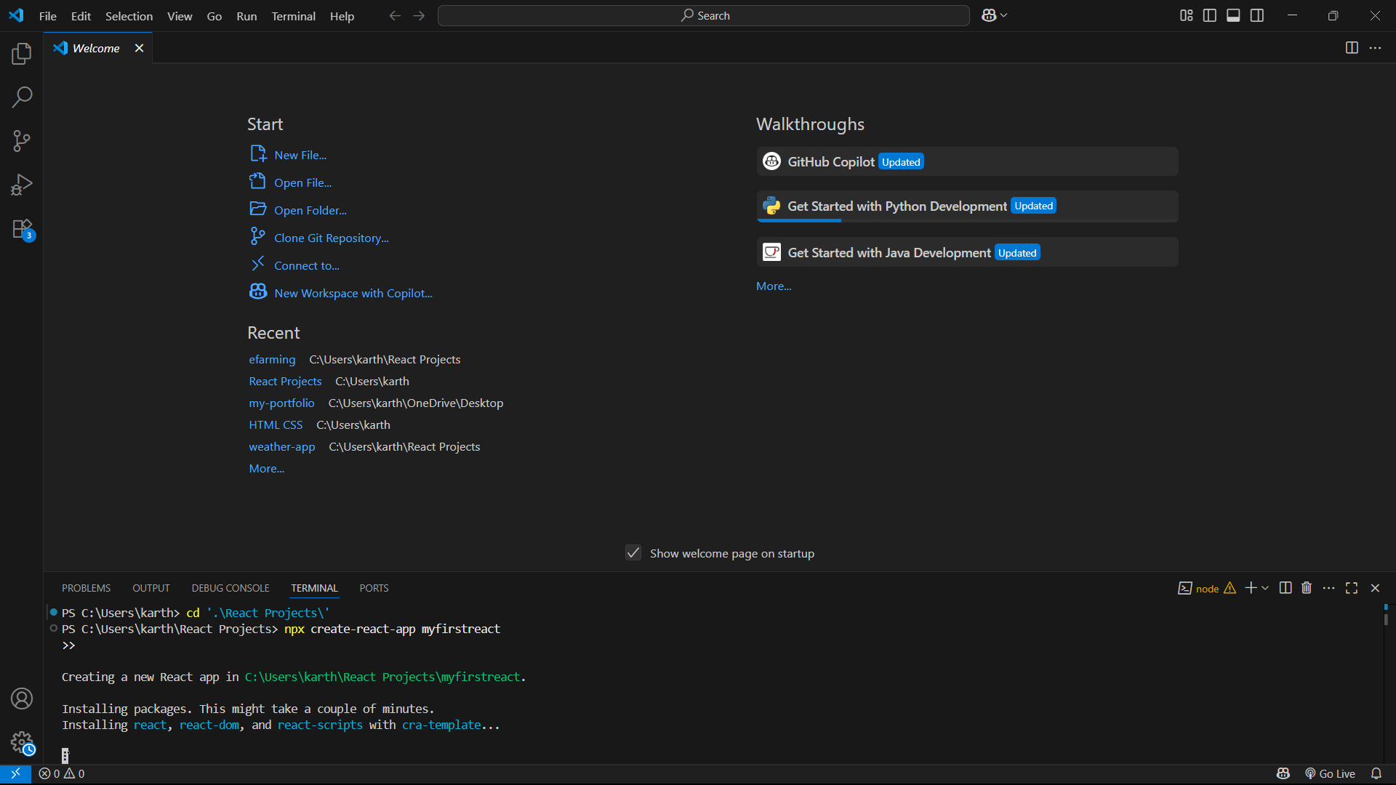
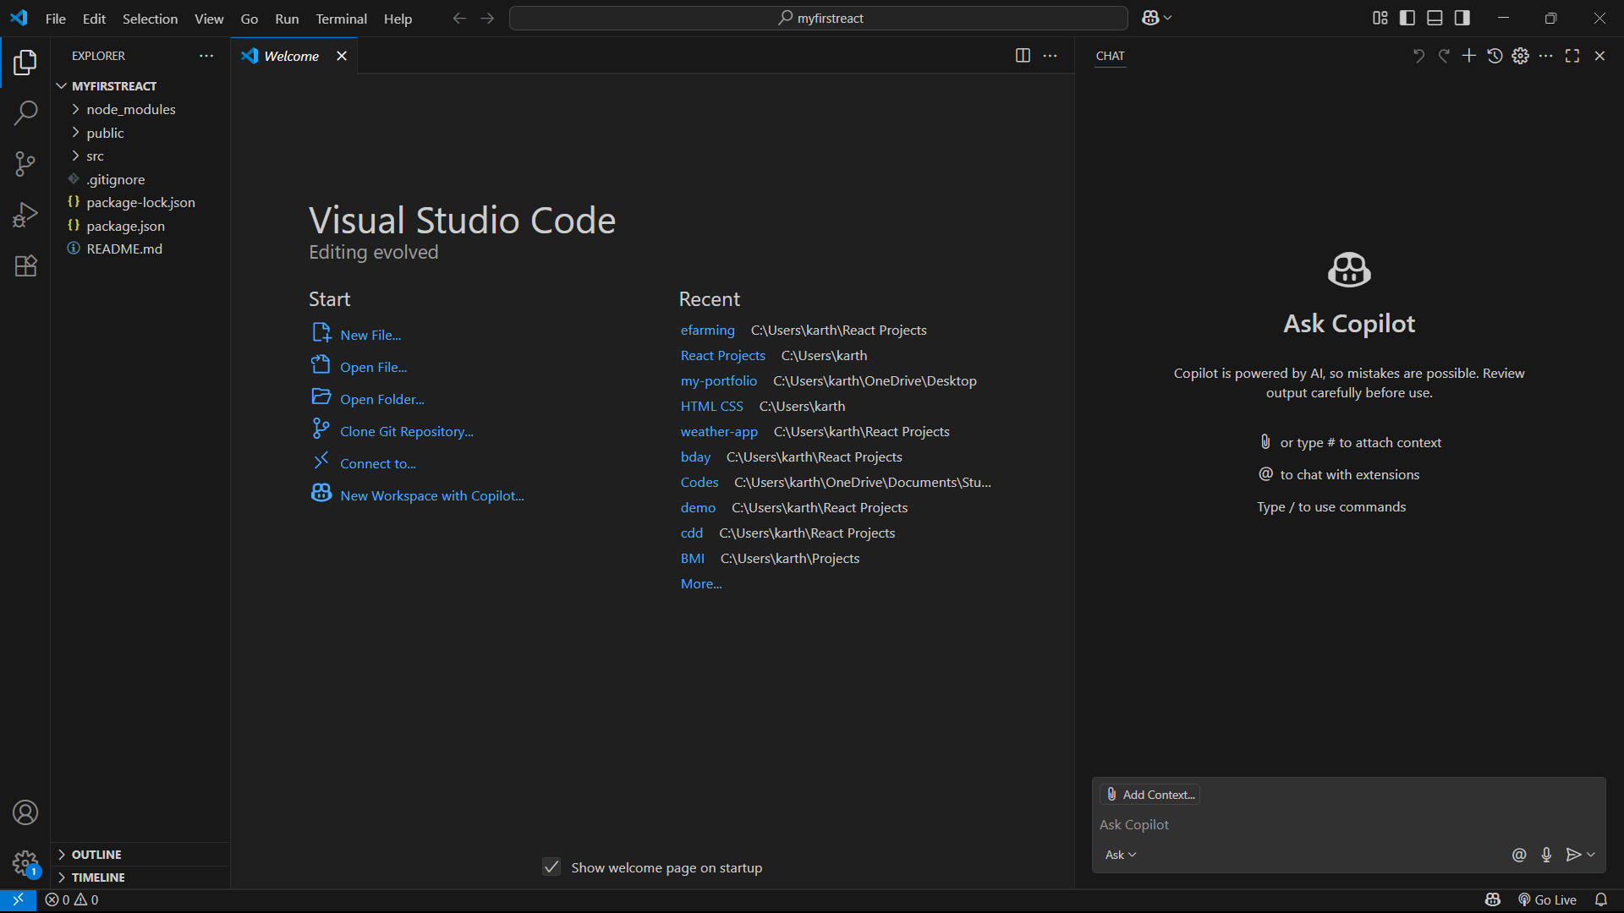
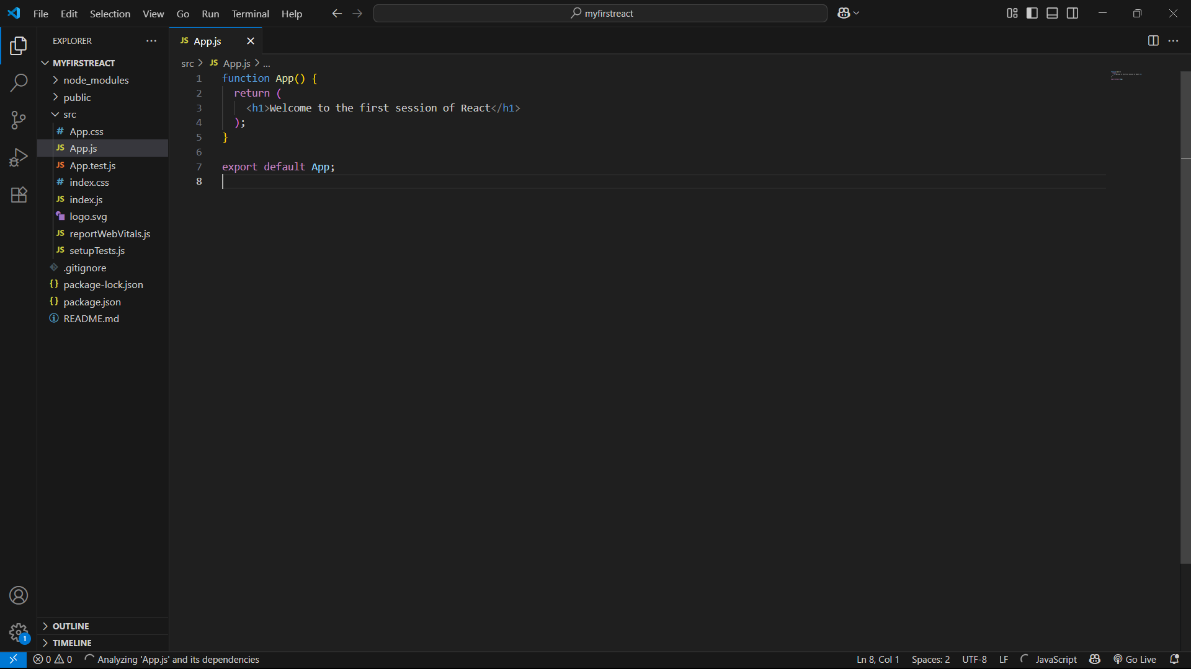
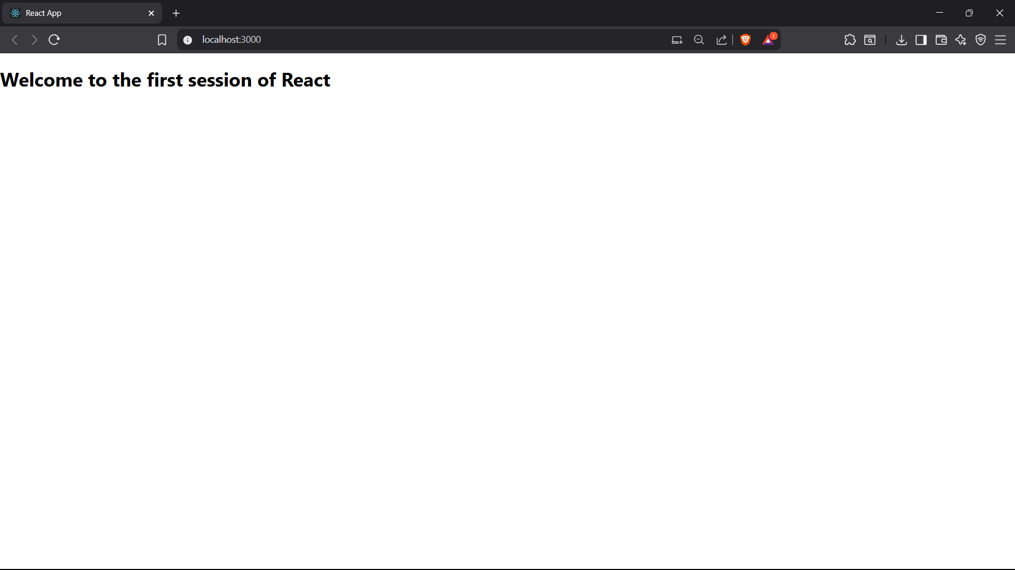

🧱 Step 1: Install Node.js and npm
- Why: React apps need Node.js to run and npm to install libraries.
- What it does: Gives you the tools to build modern JavaScript apps.
⚙️ Step 2: Install Create React App
- Why: It sets up the whole React project automatically.
- What it does: Handles configuration, folder structure, tools, etc.
🏗️ Step 3: Create a New React App
- Why: To start your own project named myfirstreact.
- What it does: Creates all files and installs React for you.
📂 Step 4: Go Into the Project Folder
- Why: You need to be inside the folder to edit or run the app.
- What it does: Prepares the terminal to work with your project.
💻 Step 5: Open the Project in VS Code
- Why: So you can write and edit code easily.
- What it does: Launches your code editor in the right folder.
✍️ Step 6: Edit App.js
- Why: To change what’s displayed on the screen.
- What it does: Replaces default code with your own message.
🚀 Step 7: Run the App
- Why: To view your React app in the browser.
- What it does: Starts a server at localhost:3000 and opens your app.

